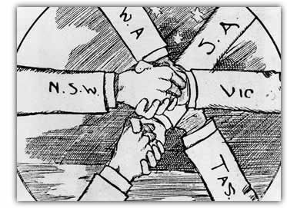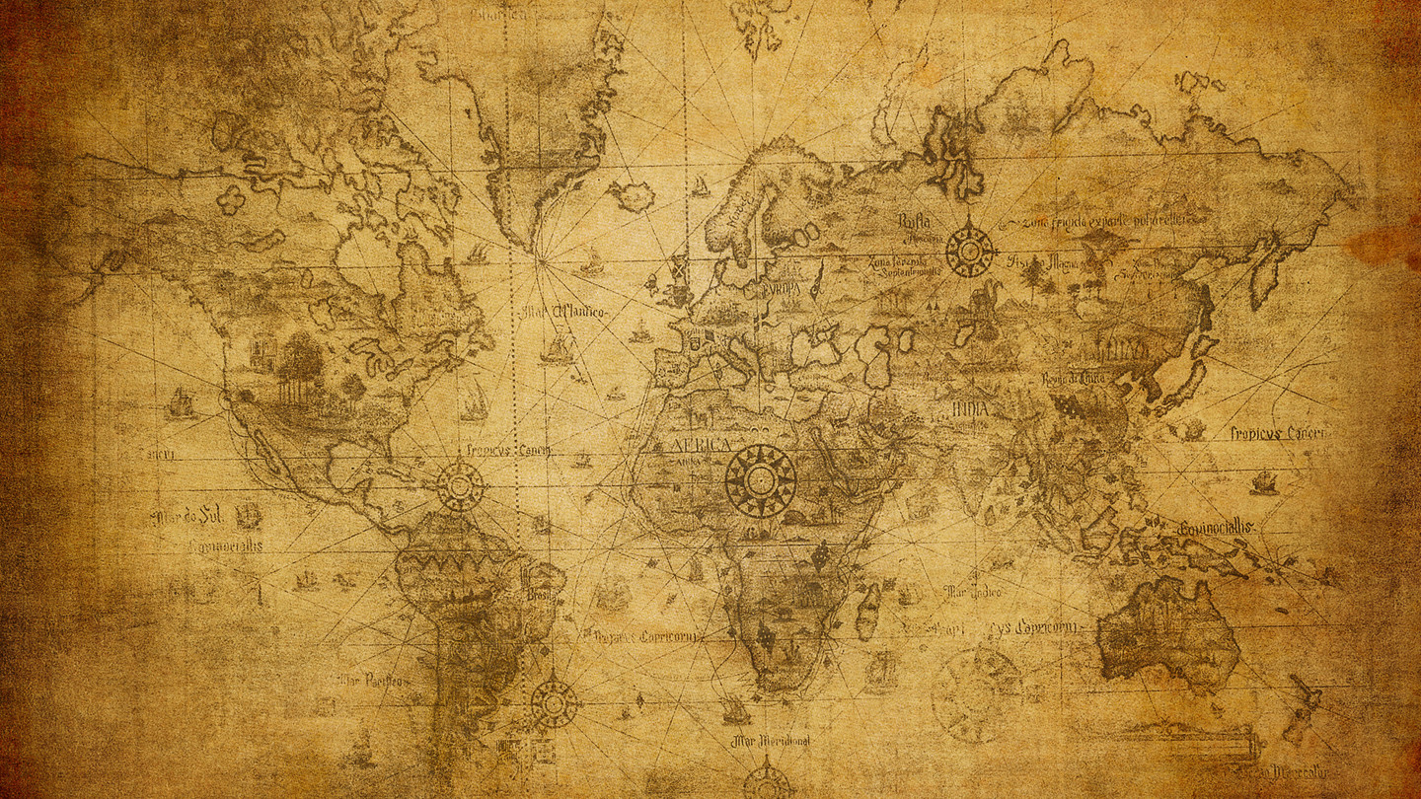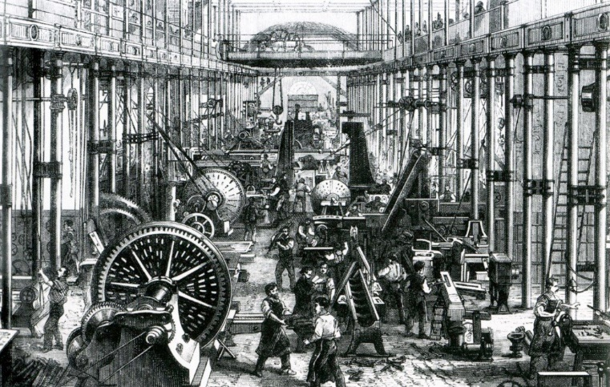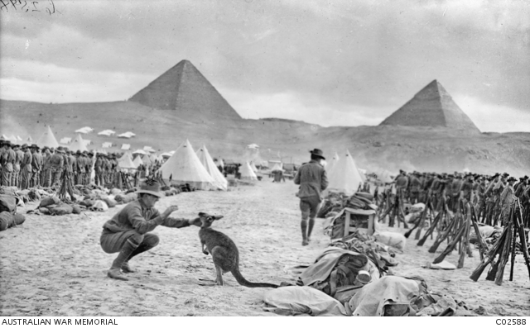

YEAR 9 HASS

**Students develop their historical understanding through key concepts, including**[**evidence**](https://k10outline.scsa.wa.edu.au/home/p-10-curriculum/curriculum-browser/syllabus/humanities-overview/glossary/evidence)**,**[**continuity**](https://k10outline.scsa.wa.edu.au/home/p-10-curriculum/curriculum-browser/syllabus/humanities-overview/glossary/continuity)**and** [**change**](https://k10outline.scsa.wa.edu.au/home/p-10-curriculum/curriculum-browser/syllabus/humanities-overview/glossary/change)**,**[**cause and effect**](https://k10outline.scsa.wa.edu.au/home/p-10-curriculum/curriculum-browser/syllabus/humanities-overview/glossary/cause-and-effect)**, perspectives,**[**empathy**](https://k10outline.scsa.wa.edu.au/home/p-10-curriculum/curriculum-browser/syllabus/humanities-overview/glossary/empathy)**,**[**significance**](https://k10outline.scsa.wa.edu.au/home/p-10-curriculum/curriculum-browser/syllabus/humanities-overview/glossary/significance)**and**[**contestability**](https://k10outline.scsa.wa.edu.au/home/p-10-curriculum/curriculum-browser/syllabus/humanities-overview/glossary/contestability)**. These concepts are investigated within the historical context of the making of the**[**modern**](https://k10outline.scsa.wa.edu.au/home/p-10-curriculum/curriculum-browser/syllabus/humanities-overview/glossary/modern)**world from 1750 to 1918. They consider how new ideas and technological developments contributed to**[**change**](https://k10outline.scsa.wa.edu.au/home/p-10-curriculum/curriculum-browser/syllabus/humanities-overview/glossary/change)**in this period, and the**[**significance**](https://k10outline.scsa.wa.edu.au/home/p-10-curriculum/curriculum-browser/syllabus/humanities-overview/glossary/significance)**of World War I.**

TERM 3 Unit Outline – History – 2024

|  |  |  |  |  |  |
| --- | --- | --- | --- | --- | --- |
| **Year 9 - History Unit Outline – Term 3, Semester 2, 2024** | | | | | |
| **The Making of the Modern World** | | | | | |
| **Week** | **Notes** | **Lesson 1** | **Lesson 2** | **Lesson 3** | **Lesson 4** |
| *Overview: The important features of the modern period (1750–1918) including technological change, Imperialism and Nationalism.* | | | | | |
| 1 |  | **Staff**  **Development**  **Day**  **(SDD)** | **Learning Intention (LI):** Revise the study of history and why we study history.  **Success Criteria (SC):**  Can recall/define the definition of History. Able to list and provide examples of why people study history and how. | **Learning Intention (LI):** Revise the study of history and the key concepts of history.  **Success Criteria (SC):** Can recall and explain the key concepts of history. | **LI:** Introduction to primary and secondary sources.  Examine the modern period (1750-1918).  **Success Criteria:** Able to describe the difference between primary and secondary sources and identify whether sources are primary or secondary.  List events during the modern period (1750-1918) |
|  | **Suggested Lesson Activities:**  PowerPoint on Learning Area Drive (Week 1) | **Suggested Lesson Activities:**  Found on HASSL Learning Area Drive.  Week 1.  Ask students the following questions to develop their conceptual understanding as the topic is taught. Introduce the following:  **Cause and effect**   * How might an invention cause a major change? * What would make an individual and/or an invention significant * **Perspective** * Why might different groups in society during the Industrial Revolution view developments and changes differently? * Why is it important to consider different perspectives/points of view, attitudes and values in the past and the present?   **Empathy**   * Why would children have accepted the situation of working in the factories and in such conditions? | **Suggested Lesson Activities:**  PowerPoint – Found on Learning Area Drive (Week 1).  Primary and Secondary Resources (Blether Stations).  **T-Chart – Comparing Sources**   * What are the differences between primary and secondary sources? * Are primary sources more reliable and useful than secondary sources?   **Evidence**   * When do sources become evidence? * How can we decide whether evidence is relevant?   Discuss types of sources we could look at when studying the Industrial revolution.  Source Analysis – look at sentence starters etc. |
| **The Making of the Modern World** | | | | | |
| **Week** | **Notes** | **Lesson 1** | **Lesson 2** | **Lesson 3** | **Lesson 4** |
| ***Overview:*** *The important features of the modern period  (1750–1918) including technological change, Imperialism and Nationalism*  ***Depth study 1: Investigating the Industrial Revolution (1750–1914)****The technological innovations that led to the Industrial Revolution, and other conditions that influenced the industrialisation of Britain (e.g. the agricultural revolution, access to raw materials, wealthy middle class, cheap labour, transport*[*system*](https://k10outline.scsa.wa.edu.au/home/p-10-curriculum/curriculum-browser/humanities-and-social-sciences/humanities-overview/glossary/system)*, and expanding*[*empire*](https://k10outline.scsa.wa.edu.au/home/p-10-curriculum/curriculum-browser/humanities-and-social-sciences/humanities-overview/glossary/empire)*) and of Australia (*[*ACDSEH017*](http://www.scootle.edu.au/ec/search?accContentId=ACDSEH017)*).*  *The population movements and changing settlement patterns during the Industrial Revolution (ACDSEH080).* | | | | | |
| 2 | *.* | **Learning Intention:**  Recap Medieval Europe – Recap on Significant Events from Medieval Times to Industrial Revolution  **Success Criteria:** Able to identify significant events from Medieval Times to the Industrial Revolution. | **Learning Intention**  Discuss the birth of and the causes of the Industrial Revolution.  **Success Criteria:**  Able to explain what causes led to the start of the Industrial Revolution. | **Learning Intention (LI):** Investigating the Industrial Revolution (1750-1914) and its impact.  **Success Criteria (SC):** Able to describe the term “Industrial Revolution” and describe some of the impacts of the industrial revolution and why it started in Britain. | **Learning Intention (LI):** Investigate the Agricultural Revolution and major changes to agriculture. (The Agrarian Revolution).  **Success Criteria (SC):** Describe what the Agricultural Revolution was, the act of enclosure and some significant inventions. |
| **Suggested Resources:**  Brainstorm on significant events from the Middle Ages and Medieval Europe.  PowerPoint on significant events (found in Learning Area drive – Week 2).  Create a timeline of the key events.  What do you Know – Industrial Revolution (WDYK) on Learning Area Drive. | **Key Inquiry Questions:**  What was the Industrial revolution?  How long did it take to start?  What were the causes?  **Suggested Resources:**  PowerPoint – Week 2 Learning Area Drive.  Ingredients for an Industrial Revolution (Learning Area Drive).  *Wolsey’s Revision Guides –* PPT in Learning Area Drive.  Graphic Organiser – Causes  Students view the 11 minute video:  *Coal, Steam and the Industrial Revolution |Crash Course World History* (PBS Learning Media) <https://www.pbslearningmedia.org/resource/2d938266-3a4e-4439-b837-17f288de6f96/coal-steam-and-the-industrial-revolution-crash-course-world-history-32/>.   * After viewing the film discuss with the class the following questions. (Write questions on the board prior to the class viewing the video.) * Why is the Industrial Revolution the most revolutionary of revolutions? * What happened to farming as a result of the Industrial Revolution? * Why did the Industrial Revolution occur in Europe, especially Britain, first? * Why did the Industrial Revolution not occur in China first, even though it had many advantages? * Why was coal so important? * Is a large population necessary for an Industrial Revolution? | **Key Inquiry Questions**  What and who did it effect?  Was it the same across all of Europe?  **Suggested Resources**  PowerPoint – who had the biggest impact.  Industrial Revolution Reading Comprehension Activity.  PPT – Effects of the Industrial Revolution  <http://www.mrpatten17.com/10.3--causes-and-effects-of-the-industrial-revolution.html>  In groups, students look at: *Inventions and Inventors of the 18th Century* on the ThoughtCo website at:  <https://www.thoughtco.com/18th-century-timeline-1992474>.  Questions that may be used with students:   * Can the inventions be categorised? * Which inventions would lead to industrial, economic or social change? * Students in groups make notes ready for a class discussion.   Ask students the following questions to bring together what has been learned about the Industrial Revolution:   * What was coal used for in the eighteenth century? * What invention was coal associated with, which transformed mining and manufacturing? * Which form of transport was an outcome of this invention? * What do you suppose is meant by: * precision manufacturing * mass production * How do the above two production methods link to cottage industries and the rise of factories? * Summing up: What were the key reasons for the Industrial Revolution occurring in Britain in the mid-eighteenth century? | **Suggested Resources:**  PowerPoint – Learning Area Drive – Agicultural Revolution and differentiated ability worksheets.  PowerPoint – Act of Enclosure  Viewing Guide – Crash Course World History Agricultural Revolution |
| **The Making of the Modern World** | | | | | |
| **Week** | **Notes** | **Lesson 1** | **Lesson 2** | **Lesson 3** | **Lesson 4** |
| **Depth study 1: Investigating the Industrial Revolution (1750–1914)**The short-term and long-term impacts of the Industrial Revolution, including global changes in landscapes, transport and communication.(ACDSEH082). The experiences of men, women and children during the Industrial Revolution, and their changing way of life (ACDSEH081) | | | | | |
| 3 | *.* | **Learning Intention:**  Understand the significance of the Industrial Revolutions effect on Industry  **Success Criteria:** Can list examples of major innovations and the impact of the revolution on the mining and textiles industries. | **Learning Intention:**  Understand the key elements, which brought about urbanisation as a result of the industrial revolution.  **Success Criteria:** Can describe the term urbanisation and the impact that the industrial revolution had on urbanisation | **Learning Intention (LI):** Understand the significance of Transport and the Industrial Revolution  **Success Criteria (SC):** Able to provide a summary key transport innovations and the development of power. | **Learning Intention:** Understand the impact that the Industrial Revolution had on working conditions.  **Success Criteria:** Can describe what working conditions were like during the industrial revolution |
| **Suggested Resources:**  Cotton Lesson Plan.  <https://hti.osu.edu/history-lesson-plans/european-history/industrial-revolution>  Divide the class into four groups and allocate one of the types of inventions in the article, *Inventors and Inventions of the Industrial Revolution*, to each group. Note: do not include #5. The internal combustion engine and automobile are not applicable to the British Industrial Revolution   * *Inventors and Inventions of the Industrial Revolution* – Britannica<https://www.britannica.com/list/inventors-and-inventions-of-the-industrial-revolution>  1. Spinning and weaving 2. The steam engine 3. Harnessing electricity 4. The telegraph and telephone.  * Students investigate and report to/share information with the class. Teacher to decide the format of the class presentation. | **Suggested Resources:**  Urbanisation Activity PPT  <https://www.aprilsmith.org/topic-2-urbanization.html>  <https://courses.lumenlearning.com/suny-hccc-worldhistory2/chapter/urbanization/>  Learning Stations Activity  <https://mskuksclass.weebly.com/lesson-2-urbanization.html>  https://www.uwec.edu/chtl/lesson-plans/high-school/urbanization-industrialization/ | **Suggested Resources:**  Pearson HASS 9 – Pages 186-189  Industrial Power PPT  Resource 2.4, 2.8 and 3.3  <https://www.internationalschoolhistory.com/lesson-4---transport.html>  <https://www.bbc.co.uk/bitesize/guides/zvmv4wx/revision/8>  <https://spartacus-educational.com/ExamIR8.htm>  https://www.econedlink.org/resources/transportation-they-say-we-had-a-revolution-part-1/ | **Suggested Resources:**  Pearson HASS 9 – Pages 190-191  <https://edsitement.neh.gov/lesson-plans/industrial-age-america-sweatshops-steel-mills-and-factories>  Conditions in the Factories PPT  Workers on the Line (WOL) program  Working Conditions – Legacy  Child Labour in the IR PPT  **Practice SOURCE ANALYSIS TASK.**  **Students complete a practice source analysis task.** |
| **The Making of the Modern World** | | | | | |
| **Week** | **Notes** | **Lesson 1** | **Lesson 2** | **Lesson 3** | **Lesson 4** |
| ***Depth study 1: Investigating the Industrial Revolution (1750–1914)****The short-term and long-term impacts of the Industrial Revolution, including global changes in landscapes, transport and communication* | | | | | |
| 4 | *.* | **Learning Intention:**  The social changes that arose because of the industrial revolution.  **Success Criteria:** Can explain why and what social changes occurred. | **Learning Intention:**  The environmental changes that resulted from the industrial revolution  **Success Criteria**  Can describe why and what environmental changes came about as a result of the industrial revolution. | **Learning Intention:**  Examine the causes and effects of inventions during the industrial revolution, including the short- and long-term changes.  **Success Criteria:**  Outline the invention, including the short and long term changes.  Outline workplace, social and economic consequences. | **Link back to Lesson One of Week 4, ‘Social Changes’.**  **Learning Intention:**  Examine the experiences of men, women and children during the Industrial Revolution, and their changing way of life  **Success Criteria:**  Outline in groups what changes have occurred.  Select five primary sources to show experiences and changing life. |
| **Suggested Resources:**  Pearson HASS 9 – Pages 200 - 203  <https://www.internationalschoolhistory.com/lesson-5---social-impact.html>  <https://courses.lumenlearning.com/boundless-worldhistory/chapter/social-change/>  <https://www.nationalarchives.gov.uk/education/resources/past-pleasures/>  (Other resources in folder).   * Use a web resource, such as: * ArcGIS – Reasons for European Exploration (ESRI) <https://www.arcgis.com/apps/MapJournal/index.html?appid=1c89578de6214fdd9b8ab157fc51acee>. * Use the questions: ‘when’, ‘where’ and ‘why’ questions in relation to exploration, industrialisation and Imperialism. * Is there a link between exploration and trade and the establishment of colonies (Imperialism)? | **Suggested Resources**  <http://resourcesforhistoryteachers.pbworks.com/w/page/124659267/Impacts%20of%20the%20Industrial%20Revolution%201730%20to%201830>  <https://www.commonsense.org/education/lesson-plans/industrial-revolution-great-britain>  https://prezi.com/6boflcmpll1p/environmental-impact-of-the-industrial-revolution/ | Use the web link below as a starting point: <https://www.britannica.com/list/inventors-and-inventions-of-the-industrial-revolution>.   * Within your group, investigate and make brief notes in terms of the Industrial Revolution in Britain. Find information on the following: * The person(s) concerned with the invention, a brief biography, especially their occupation at the time of the invention. * The invention itself. What does it do? * What changes happened as a result (both in the short-term and the long-term)? * Points could include: * Economic: the consequences for a particular industry; the rise of a merchant trading class (entrepreneurs). * Workplace: did it alter how and where people worked? * Social: was there a consequence for different groups of people? * Anything else that is significant regarding this invention.   Share information with the class. | Divide the class into at least three groups.  Each group is allocated either men, women or children as a group to investigate.  Each group researches and makes brief notes under the following headings. (See Appendix A Resource 1 for a sample note making framework.)  What was life like for the group before the Industrial Revolution (1760)?   * What changes have occurred by mid-nineteenth century for the group in terms of: * where and how the group lived * the work done/employment conditions * changes in the standard of living of the group * how the social class of the group influenced how they were impacted by the Industrial Revolution. * Each group selects **five** primary sources to show the experiences and/or the changing way of life for the group in society. (See Appendix A Resource 2 for a sample note making framework.) * Each group to present a discussion to the class addressing the following points: * The message of each source * Whether the message is the same in each source or are there differences? * Who produced the source and why? (e.g. where it was published and who was the audience?) * Is there bias evident in the source, for example is it presenting a particular point of view? (If it is a text source identify subjective language or if a pictorial source identify particular images or features of the source and explain how this shows bias.) * How useful are the five sources taken together, in showing the experiences and/or the changing way of life of the group during the Industrial Revolution? |
| **The Making of the Modern World** | | | | | |
| **Week** | **Notes** | **Lesson 1** | **Lesson 2** | **Lesson 3** | **Lesson 4** |
| ***Depth study 2: Investigating World War I (1914–1918)*** The causes of World War I and the reasons that men enlisted to fight in the war (ACDSEH021). The important features of the modern period  (1750–1918) including technological change, Imperialism and Nationalism | | | | | |
| 5 | *.* | **Learning Intentions**  Discuss key factors and concepts from the Industrial Revolution  **Success Criteria**  Identify key factors and concepts from the Industrial Revolution | **Task 1: Source Analysis Task**   * The technological innovations that led to the Industrial Revolution, and other conditions that influenced the industrialisation of Britain (e.g. the agricultural revolution, access to raw materials, wealthy middle class, cheap labour, transport system, and expanding empire) and of Australia * The population movements and changing settlement patterns during the Industrial Revolution * The experiences of men, women and children during the Industrial Revolution, and their changing way of life * The short-term and long-term impacts of the Industrial Revolution, including global changes in landscapes, transport and communication | **Learning Intentions**  Discuss the terms of imperialism, colonialism and Darwinism.  **Success Criteria**  Define the terms imperialism, colonialism and Darwinism and explain how they arose as a result of the industrial revolution and how they relate to World War I. | **Learning Intention:**  Discuss the conditions of war in the years up to WW1.  **Success Criteria:** Can describe, conditions leading up to World War 1, between 1900-1914 with a specific focus on conditions in Australia. Identify why Australia went to war. |
| **Suggested Learning Activities**  *Revision Lesson and/or Catch up lesson before Source Analysis Task.* | *Students will be completing an in-class assessment. This assessment is a source analysis task.*  **Description of task:**  Students analyse three sources  and complete a written in-class  assessment comprising of five  questions. | **Suggested Resources:**  Can be found in Learning Area Drive  <https://prezi.com/xxtw7rqn41jz/the-industrial-revolution-and-its-effect-on-world-war-1/>  Watch this video (10 minutes); a transcript with key points is available:  *Industrialization and imperialism* – Khan Academy<https://www.khanacademy.org/humanities/world-history/1600s-1800s/imperialism/v/industrialization-and-imperialism>.  As a class, discuss the connection between industrialisation and the changes to Britain’s position in the world. Consider the following:   * the importance of the steam engine * changes to transport: railways, steam ships * population changes and movement * technology, capital and productivity * raw materials and markets * if the steam engine was pivotal/essential to changes both in Britain and British influence around the world. | **Suggested Resources:**  Pearson HASS 9 – Pages 204-207    [**https://486915082902993711.weebly.com/lesson-1.html**](https://486915082902993711.weebly.com/lesson-1.html)    [**https://www.civicsandcitizenship.edu.au/cce/origins_of_wwi,24238.html**](https://www.civicsandcitizenship.edu.au/cce/origins_of_wwi,24238.html)    **https://www.westernfrontassociation.com/education/key-stage-3/complete-lessons/** |
| **The Making of the Modern World** | | | | | |
| **Week** | **Notes** | **Lesson 1** | **Lesson 2** | **Lesson 3** | **Lesson 4** |
| ***Depth study 2: Investigating World War I (1914–1918)*** The causes of World War I and the reasons that men enlisted to fight in the war (ACDSEH021) | | | | | |
| 6 | *Distribute Task 2.* | **Learning Intentions**  Discuss the causes of World War One  Discuss the terms conscription and enlistment.  **Success Criteria:**  Can identify the acronym ‘MAIN’ and explain why each of the terms contribute to the start of World War 1.  Define the terms and explain how people became soldiers in the Australian Infantry. | **Begin Task 2 –**  **Soldier Research Task**  Significant Individuals in WW1.  Inquiry Task -  Writing a Newspaper article. | **Learning Intention:**  Understand the impact of WW One through the use of propaganda to influence of the civilian population and conscription.  **Success Criteria:** Can describe what propaganda is, and explain how it was used in Australia. List effects of the use of propaganda and the effects of conscription. | **Soldier Research Lesson** |
| **Suggested Resources:**  Pearson HASS 9 – Pages 208 - 211  <https://www.uen.org/lessonplan/view/23806>  <http://resourcesforhistoryteachers.pbworks.com/w/page/124680855/Causes%20of%20World%20War%20I>  https://www.awm.gov.au/learn/schools/resources/sources/conscription  https://dl.nfsa.gov.au/module/633/#activities    https://www.sl.nsw.gov.au/learning/wwi-recruitment-conscription-propaganda  https://www.civicsandcitizenship.edu.au/cce/conscription,24246.html  <https://www.civicsandcitizenship.edu.au/cce/convincing_australia,24239.html>  The Conscription Issue – Jacaranda – pages 856 – 859.  T-Chart – Arguments for and against conscription. | **Specific Focus:**  How soldiers felt in war and How to write a newspaper article.  Getting students to use empathy and think about how their significant individuals would have felt during the war.  Discuss the requirements of the task. Discuss with the class the task, then the second part of the lesson will be commencing their inquiry task. | https://www.vic.gov.au/sites/default/files/2019-04/soap2017-lesson-4-tn.pdf    <https://www.awm.gov.au/learn/schools/resources/anzac-diversity/european-anzacs/propaganda>  Examine examples of propaganda posters.  Examine types of sources used when studying World War I.  (Pages 818-820 – New Jacaranda) |  |
| **The Making of the Modern World** | | | | | |
| **Week** | **Notes** | **Lesson 1** | **Lesson 2** | **Lesson 3** | **Lesson 4** |
| ***Depth study 2: Investigating World War I (1914–1918)*** The *causes of World War I and the reasons that men enlisted to fight in the war (ACDSEH021)*  *The places where Australians fought and the nature of warfare during World War I, including the Gallipoli campaign (ACDSEH095)* | | | | | |
| 7 | *Solider Research Inquiry – Book Labs / Computers*  *Canberra Tour Students will need to complete task prior to departure or on return from Canberra.*  *To be discussed!* | **Learning Intention:** Discuss the role of Women in WWI  **Success Criteria:** Identify significant roles that women undertook in WW1. Compare and contrast their roles before and during the war and how it relates to current women’s stereotypes.  **https://info.australia.gov.au/about-australia/australian-story/women-in-wartime**    **https://www.naa.gov.au/learn/learning-resources/learning-resource-themes/war/world-war-i/world-war-i-women-australia-after-war**    **https://www.amightygirl.com/blog?p=21319**    **https://www.theworldwar.org/learn/women**    **https://www.iwm.org.uk/history/12-things-you-didnt-know-about-women-in-the-first-world-war** | **Soldier Research Lesson** | **Learning Intention:**  Review the causes of World War One.  Understand places where Australia’s fought during the conflict.  Examine the impact of war in Australia.  **Success Criteria:** Can successfully list places where Australia’s fought during WW1 and describe what the conditions were like in Gallipoli.  **Suggested Resources:**  Pearson 9  <https://www.youtube.com/watch?v=6NhCdLE3eTg>    <https://www.sl.nsw.gov.au/learning/world-war-i-western-front>    https://www.historyskills.com/classroom/gallipoli-sample-lesson/  Jacaranda – pages 850 - 855 | **Soldier Research Lesson** |

|  |  |  |  |  |  |
| --- | --- | --- | --- | --- | --- |
| **The Making of the Modern World** | | | | | |
| **Week** | **Notes** | **Lesson 1** | **Lesson 2** | **Lesson 3** | **Lesson 4** |
| ***Depth study 2: Investigating World War I (1914–1918)*** The places where Australians fought and the nature of warfare during World War I, including the Gallipoli campaign (ACDSEH095) | | | | | |
| 8 |  | **Soldier Research Lesson** | **Learning Intention:**  Understand the nature of warfare in WW I (Gallipoli  Fighting at Gallipoli  Trench warfare  Use of tanks, aeroplanes and chemical weapons)  **Success Criteria:** Can explain the nature of warfare during WW1 and provide specific examples. | **Learning Intention:**  Understand the nature of warfare in WW I (Gallipoli  Fighting at Gallipoli  Trench warfare  Use of tanks, aeroplanes and chemical weapons)  Examine Australia’s involvement – Where did they fight?  **Success Criteria:** Can explain the nature of warfare during WW1 and provide specific examples. | **Learning Intention:** Discuss the end of World War I, including the impact on Australia’s international relations.  **Success Criteria:** Identify the significant events that led to World War 1 ending and explain the significance of the treaty of Versailles. |
|  | Pearson 9  <https://www.youtube.com/watch?v=S0t4afIEw0M>  <https://www.youtube.com/watch?v=aCbrcKqgFlY>    https://www.westernfrontassociation.com/education/key-stage-3/complete-lessons/ | <https://www.facinghistory.org/holocaust-and-human-behavior/analyzing-effects-world-war-i>  Jacaranda – pages 831-842  (Gallipoli campaign)  Jacaranda – pages 843-846. Examine life in the trenches. | https://ww1.mrdonn.org/lessonplans.html    <https://edsitement.neh.gov/lesson-plans/great-war-evaluating-treaty-versailles>  Jacaranda – Pages 870 – 873 |
| **The Making of the Modern World** | | | | | |
| **Week** | **Notes** | **Lesson 1** | **Lesson 2** | **Lesson 3** | **Lesson 4** |
| **Depth study 2: Investigating World War I (1914–1918)**  The commemoration of World War I, including debates about the nature and significance of the ANZAC legend (ACDSEH097) | | | | | |
| 9 | *Revision Lesson for Task 3 - Topic Test.* | **Learning Intention:**  Understand the nature and significance of the ANZAC legend.  Examine Australia’s involvement in WWI.  **Success Criteria:** Can describe how Australians commemorate WW1 and the impact that WW1 has had on society.  Pearson 9  Jacaranda – New text  https://anzacportal.dva.gov.au/resources/anzac-legend-great-debates | **Learning Intention:**  Review the nature and significance of the ANZAC legend.  **Success Criteria:** Can describe how Australians commemorate WW1 and the impact that WW1 has had on society.  Pearson 9  Jacaranda – New text  https://anzacportal.dva.gov.au/resources/anzac-legend-great-debates | Revision Lesson or catch up lesson to prepare for  Task 3  Review: Depth Study 2 | **Djilba Sports Carnival**  **(Thursday – Week 9 – 12 September, 2024)**  No classes |
|  |  |
| **The Making of the Modern World** | | | | | |
| **Week** | **Notes** | **Lesson 1** | **Lesson 2** | **Lesson 3** | **Lesson 4** |
| ***Depth study 2: Investigating World War I (1914–1918)*** The impact of World War I, with a particular emphasis on Australia, such as the use of propaganda to influence the civilian population, the changing role of women and the conscription debate (ACDSEH096)  *The commemoration of World War I, including debates about the nature and significance of the ANZAC legend (ACDSEH097)* | | | | | |
| 10 | *Task 3 Topic Test – this week.* | Revision Lesson in preparation for Task 3 – In-class Assessment | Task 3 – Final Topic Test.  *Includes validation from Task 2.* | **Learning Intention:**  Examine how war is commemorated.  Examine what is meant by repatriation and memorials.  **Success Criteria:**  Locate various war memorials around Australia and the world.  The next two lessons will be spent completing one of the following tasks:  **Choice 1: Create a Google Tour/Expedition** showing 8-10 war memorials around the world.  See task sheet.  Students need to have a small summary for each location. They can work in pairs.  **OR**  **Choice 2:** Thinking Big Research project – Western Front Battlefield Guides.  Page 874-875. Project Plus resource on Jacaranda Plus.  Students pick one battlefield site to research. | **Learning Intention:**  Examine how war is commemorated.  Examine what is meant by repatriation and memorials.  **Success Criteria:**  Locate various war memorials around Australia and the world.  The next two lessons will be spent completing one of the following tasks:  **Choice 1: Create a Google Tour/Expedition** showing 8-10 war memorials around the world.  See task sheet.  Students need to have a small summary for each location. They can work in pairs.  **OR**  **Choice 2:** Thinking Big Research project – Western Front Battlefield Guides.  Page 874-875. Project Plus resource on Jacaranda Plus  Students pick one battlefield site to research. |
|  |  |  |